SPI QPG6200L Programming Research

Objective
The purpose of this document is to research possible SPI solutions for programming the QPG6200L. The QPG6200L is currently set up on the custom PCB to be programming utilizing J-Tag. Through extensive testing, the team has unsuccessfully programmed the QPG and alternative solutions must be researched.

Specifications
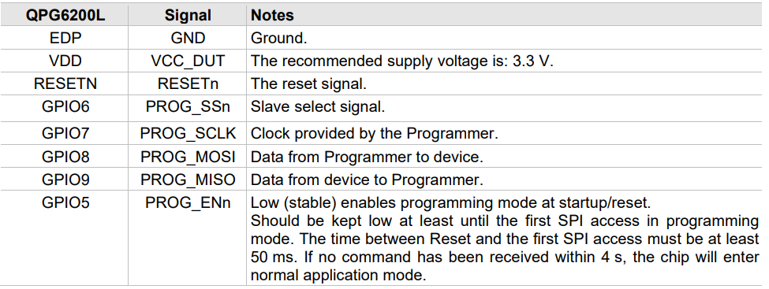
Figure 1: QPG6200L Datasheet Programming Pinouts for SPI

- Maximum SCLK frequency: 2.25 MHz
- Minimum SSn high time: 2 µs
- Minimum last SCLK to SSn high time: 10 µs.

Solutions

Adafruit FT232H
Adafruit offers a low cost USB-C to SPI module that could potentially work as a solution to SPI programming the QPG6200L. This small breakout device offers 4 pinouts for SPI that can produce PROG_SSn, PROG_SCLK, PROG_MOSI, and PROG_MISO singles to program the QPG6200L. The module includes breakout headers for various pinouts across the board making troubleshooting possible. A new 4-pin header will need to be added to QORVO_RADIO2's designed PCB to connect this device. Adafruit can also supply a 4 pin cable at an additional cost.

https://www.adafruit.com/product/2264

Raspberry Pico Development Board
The Raspberry Pico development board functions similarly to the Adafruit FT232H, as a USB-C to SPI module offering pinouts for SPI allowing QPG6200L programming. This solution does not have a dedicated header, therefore an unconventional method will be needed to connect SPI pious to the custom PCB.

https://www.raspberrypi.com/products/raspberry-pi-pico/

